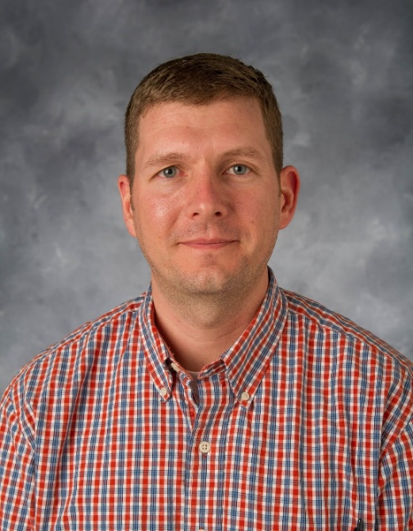

Scott K. Shaw

**Current Affiliation:** Associate Professor of Chemistry, The University of Iowa, Iowa City

**Education and Training:** Ph.D. in Chemistry, Certificate in Business Administration, University of Illinois at Urbana Champaign, 2008; B.A. of Chemistry and Secondary Education Certificate, Monmouth College, Monmouth, IL, 2003

**Professional Distinctions:** UIowa Dean’s Scholar Award (2019); NSF CAREER Awardee (2017); Cottrell Scholar Award, (2016); Monmouth College Distinguished Young Alumni (2016); ACSP2F Scholarship Award (2012); (2011) ACS-YCC Leadership Development Scholarship; YCC/CIBA ACS Travel Award Funding (2011); NSF Postdoctoral Scholar, (2010); Consultant, Sigma Technologies International, (2010); Office of Naval Research Travel Award, (2009); Marie Curie Experienced Researcher, University of Liverpool, U.K., (2009); Visiting Scientist, Durham University, U.K., (2008); Eastman-Kodak, Graduate Fellowship, (2006).

**Professional Service:** ACS Analytical Chemistry Early Career Editor, (2020); Communicating Ideas Workshop organizer, (2019-2020); ACS Science Coach for K-12 instructors, (2014-present); ACS Student chapter councilor (2012-present); Organizer for ACS and ECS meeting symposia, (2013-present)

**Summary Statement:** Research in the Shaw group can be summarized as analytical surface science. The group combines modern analytical techniques with materials and physical chemistry to create new understanding of molecular-level behaviors at interfaces. Current and start-up projects span chemical systems that are both fundamentally intriguing and extremely relevant to current needs of our technology-driven society. Advances in these areas allow predictive design of new, improved devices in a range of applications including energy production, corrosion science, and environmental remediation. Experimental techniques encompass surface-sensitive optical spectroscopies, non-linear spectroscopies, probe microscopies, electrochemical methods, tensiometry, and novel sample preparation techniques, all targeted at revealing the interfacial properties of otherwise opaque chemical systems.